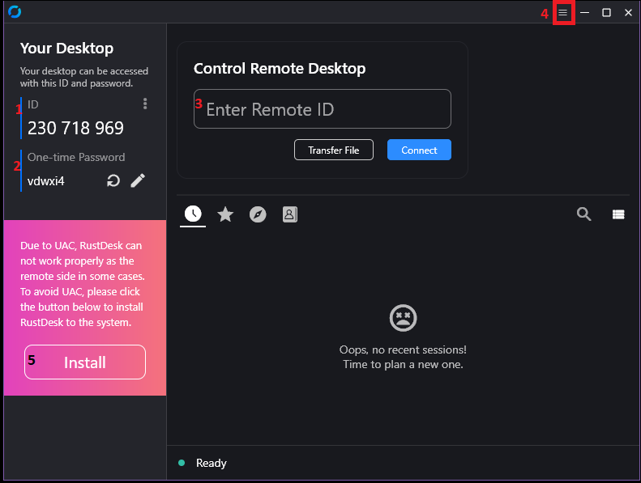

1. Your ID that is given to grant remote access
2. Password given to support tech for remote access
3. Field to input the customer’s remote ID.
4. Click to open the settings tab
5. Clicking this will prompt you to install RustDesk as a regular application. Only do this if there are issues running RustDesk from the standalone executable.

After typing in the customer’s ID and clicking connect you will be asked for their password. They can give you the password or click Accept when they are prompted.

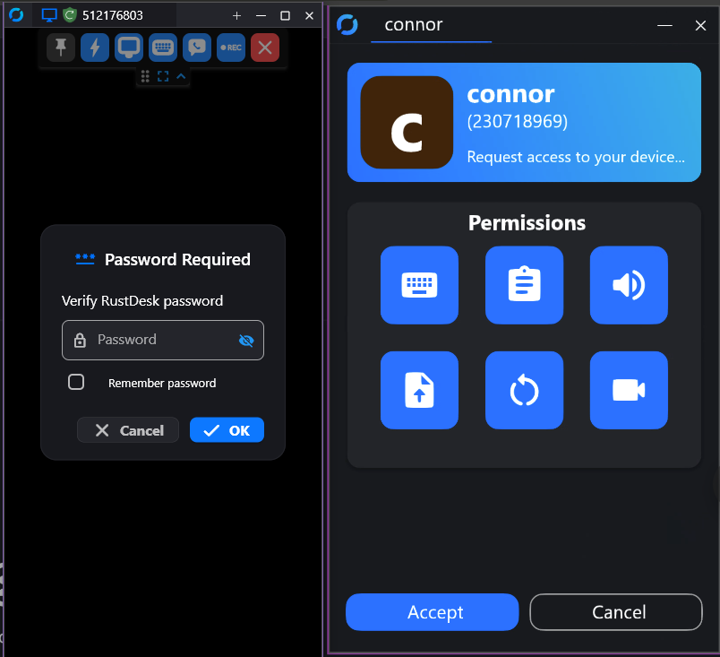

If the customer’s screen doesn’t load properly, you can change the resolution to “Scale Adaptive” by clicking on the monitor icon during an active session. You can also check the box for “Show remote cursor” to always see where the customer moves their mouse.

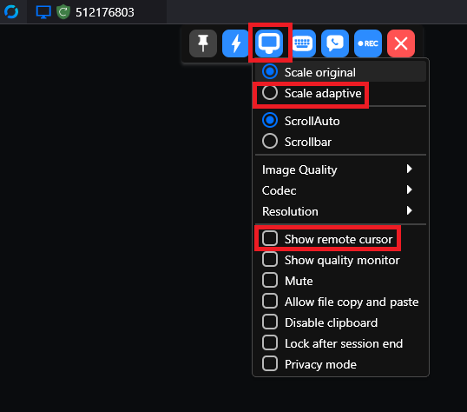

To perform a file transfer, click the lightning bolt icon in your active session, the Transfer file:

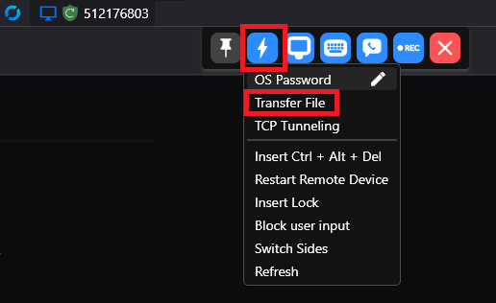

You will be prompted for the customer’s password, or they can accept the file transfer request:

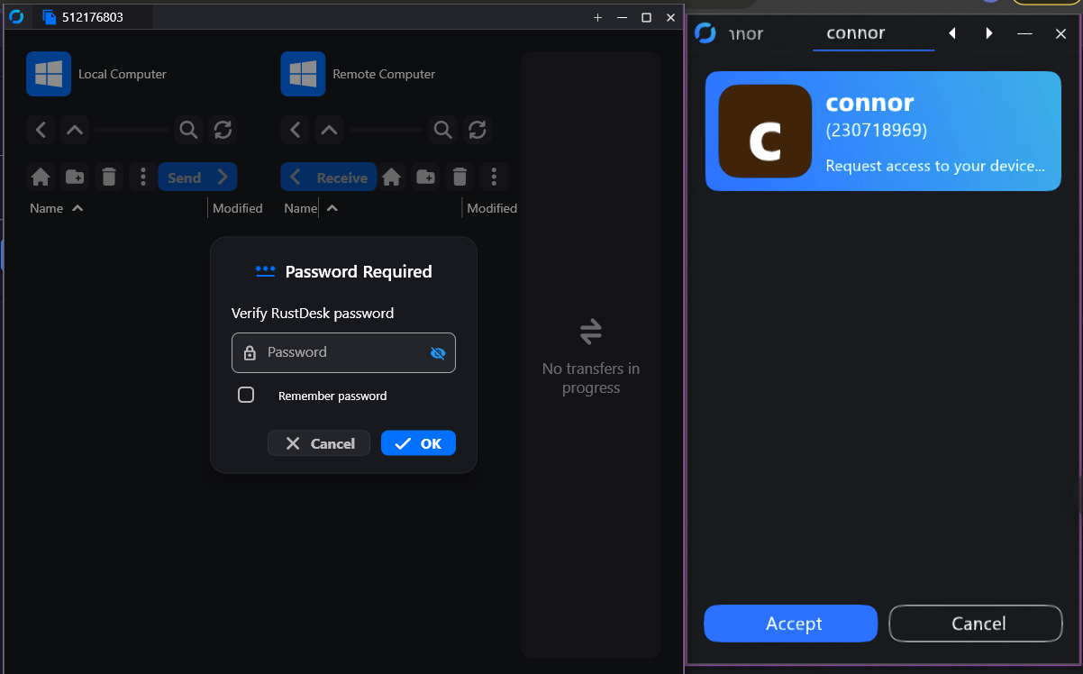

Once the interface loads, the files on your PC are on the right and the customer’s PC is on the left. Browse to the file you want to transfer, highlight it and click send or receive to move it between PCs:

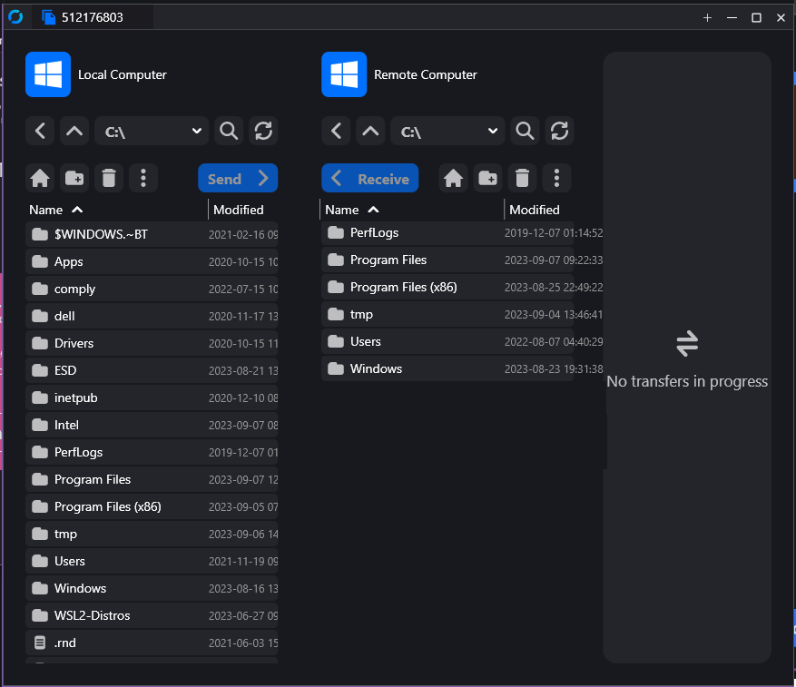

Troubleshooting:  
If RustDesk isn’t working right for a customer, use Quick Assist to get remote access. Once you are on the customer’s PC click the start menu and simply type %appdata% and press enter(1). A new file explorer window will pop up taking you to the user’s AppData/Roaming directory. Look for the RustDesk folder and delete it(2) (make sure RustDesk isn’t running in Task Manager).  
