1. Use TeamViewer to access the handheld device
2. On the device go to installs.sscsinc.com/rustdesk
3. Click RustDesk-android to download the apk
4. Open the apk once it finishes downloading

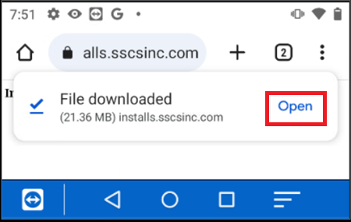

1. When prompted tap Settings

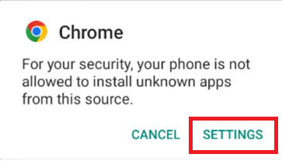

1. Toggle “Allow from this source” to enable installing the apk
2. Press the back arrow in the top left corner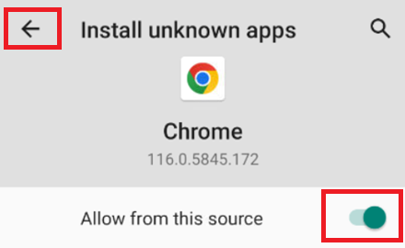
3. Tap install when prompted

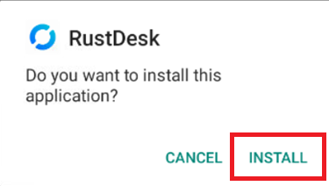

1. Open the RustDesk App after it finishes installing. Click on Settings(1), then click the icon in the top-right corner(2) to open the QR code scanner. 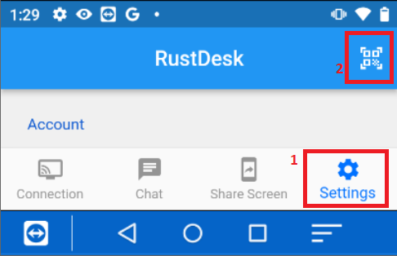
2. When prompted allow, RustDesk to use the camera

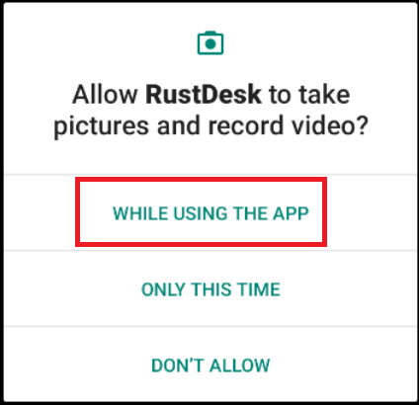

1. You will need to have the customer use a PC or cell phone to browse to installs.sscsinc.com/rustdesk to load the QR code for our server configuration.
2. Once the QR code is scanned you’ll see a form with the Server ID and Key fields filled out. Click OK to save the config.
3. Go to the Screen Share (1) page and enable Screen Capture (2), Input Control (3), Transfer File (4). You will have to follow the prompts to grant each permission. Once all 3 are enabled, the service will need to be started manually for each screen share session (5)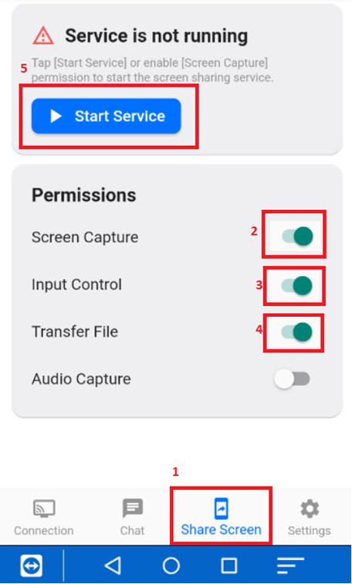
4. Screen Capture prompt: 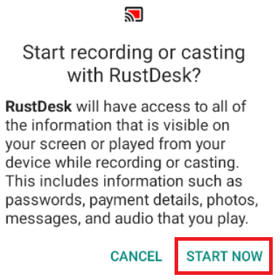
5. Input Control Prompt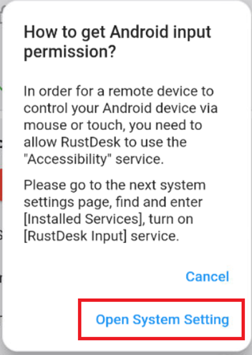

(3) 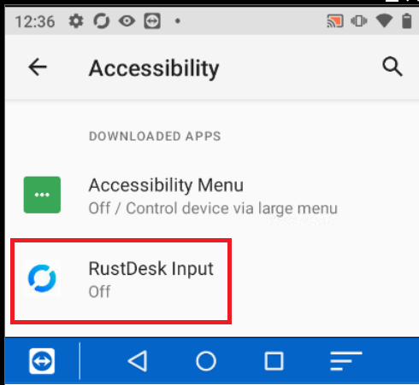

(3) 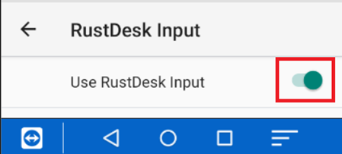

(3)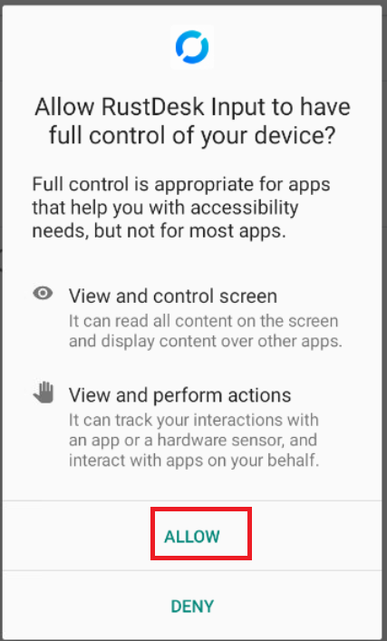

1. Transfer File prompt 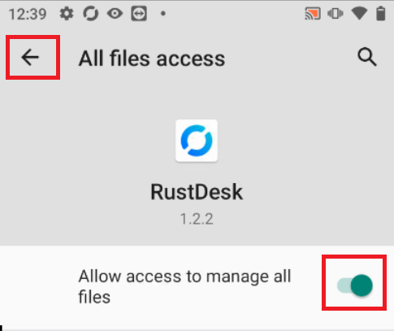

14) You can now use RustDesk to remotely control the handheld device. Have the user open the app, tap the Screen Share button, then tap Start Service. Once the service is running their ID and password will generate. Continue to the next page.

The navigation buttons for the device can be shown or hidden by pressing the Phone button in the toolbar during an active session. Be careful, you can hide the buttons by clicking the down arrow highlighted in yellow

